PRESS RELEASE

COMMUNICATIONS AND MEDIA TEAM OF THE 2023 ASEAN SUMMIT

No.71/SP/TKM-ASEAN2023/ENG/5/2023

Indonesian President to Chair Two Meetings on Last Day of the 42nd ASEAN Summit 2023.

West Manggarai, 11 Mei 2023 – On the last day of the 42nd ASEAN Summit in 2023, Indonesian President Joko Widodo will chair two out of the three meetings scheduled for Thursday, May 11.

This was announced by the Spokesperson for the Indonesian Ministry of Foreign Affairs, Teuku Faizasyah, in Labuan Bajo, West Manggarai Regency, East Nusa Tenggara Province.

"Today is the second and last day of the 42nd ASEAN Summit where three meetings will take place," said Teuku Faizasyah on Thursday, May 11, 2023.

The two meetings to be chaired by the President are the Retreat Session and the Indonesia-Malaysia-Thailand Growth Triangle (IMT-GT) Summit.

Meanwhile, the Brunei-Indonesia-Malaysia-Philippines East ASEAN Growth Area (BIMP-EAGA) Summit will be chaired by Malaysian Prime Minister Anwar Ibrahim as Malaysia currently holds the chairmanship of BIMP-EAGA. All three meetings will take place at the Meruorah Hotel, Labuan Bajo.

As previously reported, on the first day of the 42nd ASEAN Summit in 2023, President Joko Widodo chaired five meetings, including the Opening and Plenary Session, ASEAN Leaders' Interface with the ASEAN Inter-Parliamentary Assembly (AIPA) Representatives, ASEAN Leaders' Interface with ASEAN Youth Representatives, ASEAN Leaders' Interface with the ASEAN Business Advisory Council (ASEAN-BAC) Representatives, and ASEAN Leaders' Interface with the High-Level Task Force on ASEAN Community’s Post-2025 Vision (HLTF-ACV).

The entire program of the 42nd ASEAN Summit in 2023, which was attended by eight ASEAN Heads of State or Government, the ASEAN Secretary-General, and the Prime Minister of Timor-Leste, will be concluded with a press conference by President Joko Widodo at the Media Center, Bintang Flores Hotel, Labuan Bajo, on Thursday, May 11, 2023. (Kemlu/TR/Elvira)

***

For further information, please contact the following:

Director for Information and Media, Ministry of Foreign Affairs - Hartyo Harkomoyo (0811831899).

Get more information at http://asean2023.id, https://infopublik.id/kategori/asean-2023, and https://indonesia.go.id/kategori/ragam-asean-2023

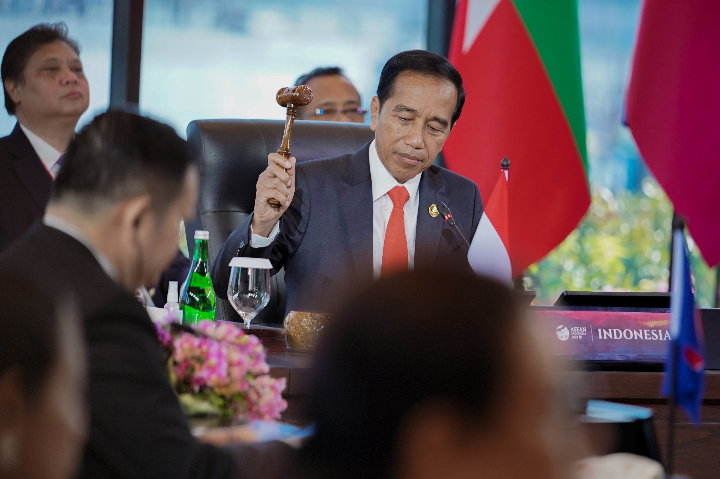

President Joko Widodo officially opens the 42nd ASEAN Summit at Hotel Meruorah, Labuan Bajo (10/5/2023). (Photo: ASEAN2023 Host Photographer)

